1.Define Artificial Intelligence? List out the various vocabulary of AI

# 2.List and discuss various branches of AI

# 3.What are the Task domains of AI? Discuss in details

# 4.What are the desirable properties of Knowledge?

# 5. What are the questions to be answered to solve the AI problem?

# 6. How does the various levels of AI model is represented?

# 7. What are the steps to be followed in solving the AI problems?

# 8. Discuss the properties of problems space and search for the optimal solution?

# 9. What are the various applications of AI?

# 10. What are the elements of formal description of the AI problem

# 11. . Discuss the water jug problem as case study for AI problem solving

# 12. What is a production system? Discuss the various elements of production system

# 13. What are the steps involved in Heuristic search technique

# 14. What is Heuristic control strategy? What are its properties?

# 15. Discuss the various problem characteristics to be considered while choosing the appropriate control strategy

# 16. What are the characteristics of the control strategy? List out the issues while choosing the control strategy.

# 17. Write the steps involved in Generate and Test Algorithm? Discuss its properties

# 18. What is philosophy behind simulated annealing? Discuss the steps

# 19. With the help of an Algorithm, discuss the properties and working of A* algorithm

# 22. How does the Best first search is considered as a special case of A* algorithm. With the help of algorithm and case study discuss its working

# 20.Discuss the working Agenda driven search with the help of algorithm

# 21. Write algorithm for AO* algorithm? Discuss with examples

# 23. With the help algorithm, discuss how constraint satisfaction helps in finding the optimal solution

# 24. With a case study, discuss the working of Means-end-analysis ---see pdf.

# 25 .With the help of case studies and algorithm, discuss the working of Problem reduction --- see pdf..

1.Define Artificial Intelligence? List out the various vocabulary of AI

● Definition: Artificial Intelligence is the study of how to make computers do things, which, at the moment, people do better

. ● According to the father of Artificial Intelligence, John McCarthy, it is “The science and engineering of making intelligent machines, especially intelligent computer programs”.

Artificial Intelligence is a way of making a computer, a computercontrolled robot, or a software think intelligently, in the similar manner the intelligent humans think.

AI Vocabulary:

Intelligence, Intelligent behaviour, Learning

Science based goals of AI, Engineering based goals of AI, AI Techniques

# 2.List and discuss various branches of AI

● Logical AI — In general the facts of the specific situation in which it must act, and its goals are all represented by sentences of some mathematical logical language. ○ The program decides what to do by inferring that certain actions are appropriate for achieving its goals.

● Search — Artificial Intelligence programs often examine large numbers of possibilities – for example, moves in a chess game and inferences by a theorem proving program. ○ Discoveries are frequently made about how to do this more efficiently in various domains.

● Pattern Recognition — When a program makes observations of some kind, it is often planned to compare what it sees with a pattern. ○ More complex patterns require quite different methods than do the simple patterns that have been studied the most.

● Representation — Usually languages of mathematical logic are used to represent the facts about the world.

● Inference -- Mathematical logical deduction and default reasoning or non-monotonic reasoning

○ It is the possibility that a conclusion may have to be withdrawn that constitutes the non-monotonic character of the reasoning ○ Normal logical reasoning is monotonic, in that the set of conclusions can be drawn from a set of premises

● Common sense knowledge and Reasoning — This is the area in which AI is farthest from the human level

● Learning from experience — There are some rules expressed in logic for learning. Programs can only learn what facts or behaviour their formalisms can represent

● Planning — Planning starts with general facts about the world (especially facts about the effects of actions), facts about the particular situation and a statement of a goal. ○ From these, planning programs generate a strategy for achieving the goal

● Epistemology — This is a study of the kinds of knowledge that are required for solving problems in the world.

● Ontology — Ontology is the study of the kinds of things that exist.

● In AI the programs and sentences deal with various kinds of objects and we study what these kinds are and what their basic properties are

● Heuristics — A heuristic is a way of trying to discover something or an idea embedded in a program.

● Heuristic functions are used in some approaches to search or to measure how far a node in a search tree seems to be from a goal.

● Heuristic predicates that compare two nodes in a search tree to see if one is better than the other, i.e. constitutes an advance toward the goal, and may be more useful. ● Genetic programming — Genetic programming is an automated method for creating a working computer program from a high-level problem statement of a problem. ○ Genetic programming starts from a high-level statement of ‘what needs to be done’ and automatically creates a computer program to solve the problem. ○ Neural Computing and Fuzzy techniques ○ Neural Computing deals with development of capabilities of human brain ○ Fuzzy techniques are adapted to address the problems of uncertainity

# 3.What are the Task domains of AI? Discuss in details

**Mundane Tasks**

* **Perception :** 1.vision

2.Speech

* **Natural Language :** -Understanding ,Generation ,Translation
* **Robot control**
* **Common sensing**
* **Formal Tasks:**
* **Games:** Chess, Backgammon, Checkers-go
* **Mathematics:** Geometry, Logic, Integral calculus, Proving properties of programs.
* **Expert tasks:**
* **Engineering:** Design, Fault finding, Manufacturing planning
* **Medical diagnosis**
* **Financial analysis**
* **Scientific analysis**

**4.What are the desirable properties of Knowledge?**

The knowledge possesses desirable properties.

○ It is not huge.

○ It is not difficult to characterize correctly.

○ It is not constantly varying.

○ It does not differs from data by being organized in a way that corresponds to its application.

○ It is not much complicated.

# 5. What are the questions to be answered to solve the AI problem?

● What are the underlying assumptions about intelligence?

● What kinds of techniques will be useful for solving AI problems?

● At what level human intelligence can be modelled?

● When will it be realized when an intelligent program has been built?

# 7. What are the steps to be followed in solving the AI problems?

To solve the problem of building a system you should take the following steps:

● Define the problem accurately including detailed specifications of what constitutes a suitable solution.

● Analyse the problem carefully, for some features may have a impact on the chosen method of solution.

● Segregate and represent the background knowledge needed in the solution of the problem.

● Choose the best solving techniques to solve the problem

# 9. What are the various applications of AI?

∙ Perception

■ Machine vision

■ Speech understanding

■ Touch ( tactile or haptic) sensation ∙ Robotics

∙Natural Language Processing

■ Natural Language Understanding

■ Speech Understanding

■ Language Generation

■ Machine Translation

∙ Planning

Expert Systems

∙ Machine Learning

∙ Theorem Proving

∙ Symbolic Mathematics

∙ Game Playing

11. . Discuss the water jug problem as case study for AI problem solving

● Given two jugs A and B of capacity 4 liters and 3 litres, the goal is to have only two litres to be filled in A. ● The state space is a set of pairs, giving the amount of water in both the jugs at any given time i.e, (a,b), where a=0,1,2,3,4 amd b=0,1,2,3 ● The set of production rules/operators are as given below

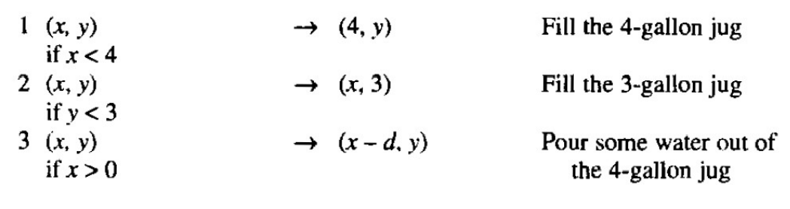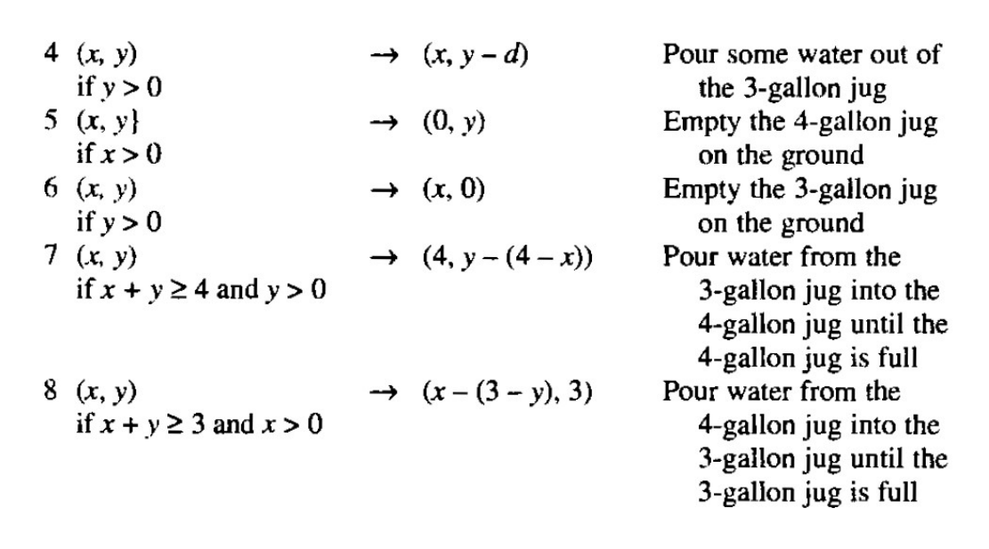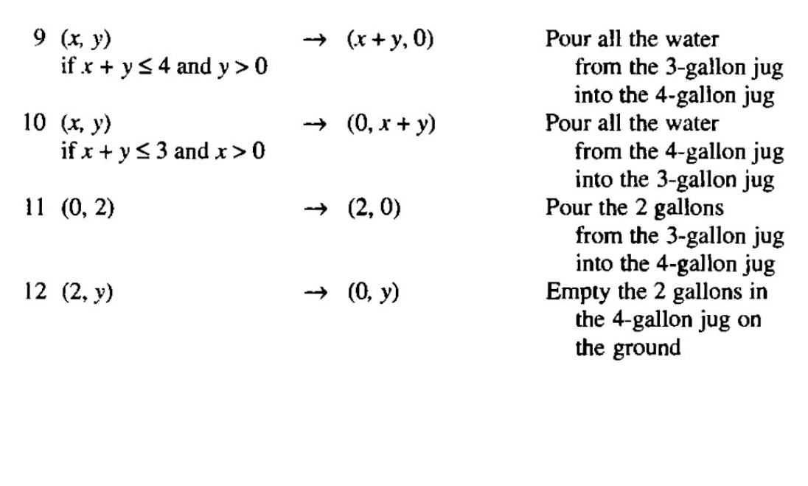

# 12. What is a production system? Discuss the various elements of production system

It provides a structure to the AI Programs.It consists of following elements

○ A set of rules of the form A◊ B, where A specifies the applicability of rule and theB specifies end result

○ One or more knowledge/database specifying information appropriate for the task to be performed

○ A control strategy which specifies the order in which the rules to applied and resolve the conflicts in making a right choice ○ A rule executor

● Along with these it also encompasses a set of production system interpreters necessary to handle

# 13. What are the steps involved in Heuristic search technique

● For finding a solution, by using the heuristic technique, one should carry out the following steps:

○ Add domain—specific information to select what is the best path to continue searching along.

○ Define a heuristic function h(n) that estimates the ‘goodness’ of a node n. Specifically, h(n) = estimated cost(or distance) of minimal cost path from n to a goal state.

○ The term, heuristic means ‘serving to aid discovery’ and is an estimate, based on domain specific information that is computable from the current state description of how close we are to a goal.

# 17. Write the steps involved in Generate and Test Algorithm? Discuss its properties

Generate and Test Algorithm

● Generate a solution. i.e., a solution point in problem space or generating a path in search space

● Test the acceptability of the solution by comparing with the expected end point or solution path

● If the solution is acceptable quit, else return to step

1.Properties of Generate and Test

● It is almost like a DFS/exhaustive search/British museum search, where the each solution is tested before heading towards completeness

● An exhaustive generate and test, simply generates all possible solutions and test for its fitness ( E.g. four cubes with six colours)

● A heuristic generate and test, consider the fact that one of the colour is repeated most and need to be ignored

● In this way many solution configurations can be ignored to find the quicker solution

● Other way is to combine with other techniques such as constraint satisfaction in case of plan-generate-test ( Chemical analysis)

● Hence, generate-test can become a judicious reference for the planning to effective, as in planning there is no feedback from the system.

# 18. What is philosophy behind simulated annealing? Discuss the steps

Simulated Annealing

● Making few downhill moves along with hill climbing to do enough explorations so as to minimize the effect of choice of initial state

● Here we consider objective function in place of heuristic function and perform valley descending/minimization in place of climbing/maximization

● Similar to the concept of the physical system changing their state of high energy to low energy naturally (molten state to cool state)- Annealing

● The process of attaining the state of annealing may be rapid or slow, this is called as annealing rate or schedule.

Simulated annealing Algorithm

● Evaluate the initial state. If it is goal quit else continue

● Initialize BEST-SO-FAR to current state

● Initialize T as annealing schedule

● Loop until a solution is found

○ Select an operator to current state to produce next state

○ Compute

■ If goal state quit else make it BEST-SO-FAR

■ If it is not better, make it current state with a probability p.

○ Revise T if necessary

● Return BEST-SO-FAR as answer

# 19. With the help of an Algorithm, discuss the properties and working of A* algorithm

A* Algorithm Algorithm

● Start with OPEN containing initial node with g=0 and h’ with some estimate and f’=g+h’. Keep the CLOSED empty

● Until the goal is found, Repeat the following

○ If there are nodes in OPEN, pick a node with lowest f’ as the BESTNODE, place it in CLOSED

○ If BESTNODE is the goal return else generate SUCC and follow the steps below

■ For each SUCC, point back to BESTNODE

■ Compute g(SUCC)= g(BESTNODE)+cost of BESTNODE TO SUCC

■ If SUCC is in OPEN, then call it OLD and add it to BESTNODE’s successor

■ If the cost to SUCC node from BESTNODE is cheaper than the cost of OLD node, then update the parent of OLD node to BESTNODE. Record g(OLD) and update f’(OLD)

■ If SUCC is in CLOSED, then call it OLD and update the better cost, new parent and explore its successors using DFS

■ If the node is neither in OPEN nor in CLOSED, then place it in OPEN and compute f’A* Algorithm

● Best first search is derived from A* algorithm

● It considers both the goodness of a node and the path to it

● The function g and h’ decides the characteristic behaviour of the algorithm

● The function g can be configured to explore either the goal or the shortest distance to the goal

● If g=0, then the search is random, if g=1, then the search is breadth first and if h’=0 then the search is controlled by g.

● The function h’ can be underestimated or overestimated

● Another issue is to whether to use graph or tree.

# 20.Discuss the working Agenda driven search with the help of algorithm

Agenda driven search

● It is the process by which the search explores most “interesting” path to be explored.

● The merit of a node measured by h’ lies in exploring the path which is of most interest.

● Each task of exploring new path, depends on the reasons for choosing it and the reasons to be considered as agenda

Agenda driven search Algorithm

● Do until the goal is reached or agenda is empty

○ Choose the most promising task (node) from the agenda

○ Explore the task to generate few more tasks(nodes)

■ For each node, check the agenda list, if it is already listed then ignore, else add it to the agenda list

■ Compute the strength of the reason/justification, and this decides the rating of the task chosen

● Here, the challenge is to keep the right justification updated and agenda list sorted upon interest.

● As the justification changes, the rating changes and the algorithm will spend lot of time in doing same

● To avoid the complexity, the task is compared with only top few agenda in the list and proceed.

● Can also look for negative agenda to simplify the choice

● The time complexity also depends on the grain size of each task, smaller the task too many comparisons.

21. Write algorithm for AO* algorithm? Discuss with examples

AO8 Algorithm Algorithm

● Let the GRAPH start with INIT and h’(INIT)

● Until INIT is labelled solved or if h’(INIT) is greater than FUTILITY, repeat

○ Select one of the next unexpanded node NODE in the path

○ If there are no successor of NODE, then assig h’ as FUTILITY and it is unsolvable, else for each SUCC, which is not visited earlier

■ Add SUCC to GRAPH

■ If SUCC is terminal, then the label is solved and h’=0 else h’ is computed.

○ Propagate the newly computed information up the graph using a set of solved nodes called S

■ Select a node from S whose descendants are not in GRAPH, call this as CURRENT

■ Compute CURRENT’s h’

■ Mark the CURRENT as SOLVED if it has the minimum h’

■ These changes need to be propagated back to its ancestorsAO* algorithm

● When the cost of each SUCC is computed and propagated back to the root, the choice of path will also get up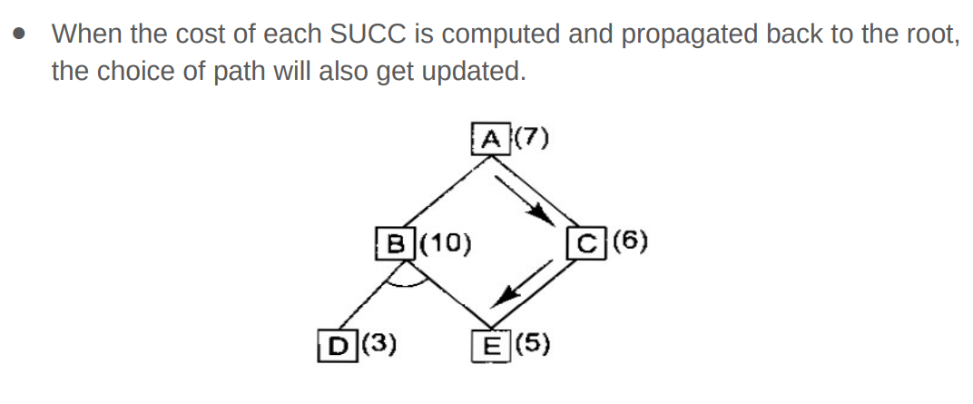dated.

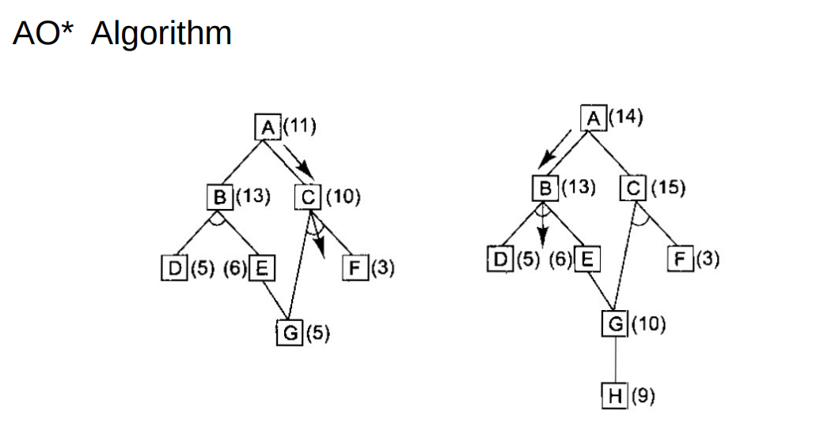

# 23. With the help algorithm, discuss how constraint satisfaction helps in finding the optimal solution

Constraint Satisfaction

● Most of the problems can be treated as Constraint satisfaction problem before addressing the optimal solution

● This aims at a substantial reduction in the amount of the search required and it operates in a space of constraint sets.

● The constraints may be dependent and unless it is resolved the process of search may end up in failure

Constraint Satisfaction Algorithm

● Propagate available constraints, setting OPEN as a list of objects coming under constraints

○ Apply each constraint in OPEN and strengthen the object ○ Add all objects to OPEN which are dependent on a particular constraint

● If union of all constraints defines a solution then exit else failure ● Else Repeat addressing each constraint towards convergence of the solution